A meeting at the Cultural Attaché in London
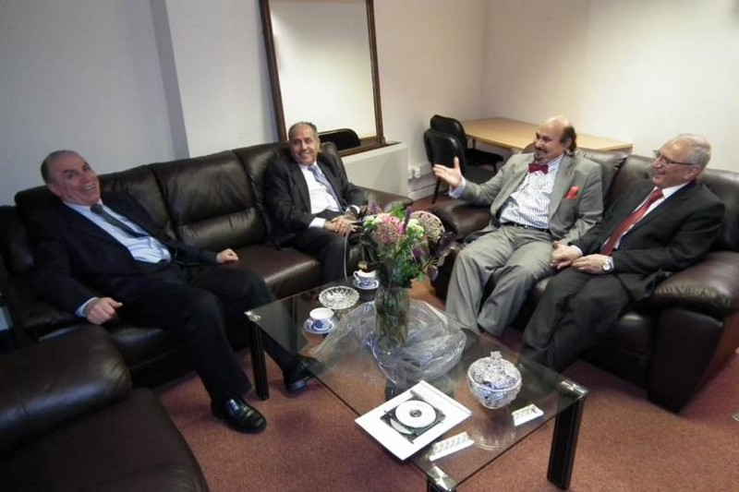
Professor Abdul Razzaq Al-Essa, the cultural advisor met a delegation from the Network of Iraqi Scientists Abroad (NISA) on 21 December 2011 to explore ways to expand cooperation between the attaché and NISA. The following action plan was proposed:
1) NISA to assist students who obtained scholarships from Iraqi universities by offering PhD places in their research groups and to assist other students to find places in other areas at their universities.
2) NISA members are to participate in the evaluation of research output for promotions and to give scientific advice and help in reviewing manuscripts for publication in scientific journals.
3) To increase the participation of NISA members in Iraqi scientific conferences, to give lectures to graduate students and to set up training courses and workshops.
4) To hold an annual scientific conference for Iraqi graduate students in UK, to honour the outstanding students, prominant scientists and innovators, and to build a cooperation with academics, doctors and engineers and their organisations in the United Kingdom.
The cultural advisor nominated Mohamed Al-Rubeai, Kadim Al-Lami and Hamid Al-Roushedi as advisors to the Attaché.
It was also agreed to establish regular seminars and lectures organised by NISA in cooperation with the attaché to be held in the attaché meeting hall on topics of science and technology. The seminars will be chaired by Professor Hamid Al-Roushedi.

