In Support of Scientific Research
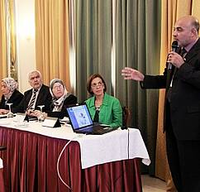
© Elias Abu Judeh/ 2011Participants discuss the status of scientific research in Iraq in a workshop from 27-28 September in Beirut.

On 27 and 28 September, UNESCO Iraq held a workshop for 15 senior Iraqi officials to discuss the status of Scientific Research in Iraq
In cooperation with the Ministries of Higher Education and Scientific Research in Baghdad and Erbil, UNESCO Iraq conducted a workshop in Beirut on the status of Scientific Research in Iraq within the framework of the project “Rehabilitating Higher Education in Iraq”, funded by the Office of Her Highness Sheikha Moza bint Nasser. Held from 27-28 September, it brought together 15 senior Iraqis including the Director Generals of Scientific Research in line ministries as well as the Ministries of Planning, Industry and Minerals and Science and Technology to discuss the state of scientific research in Iraq.
The first version of the report under discussion was the result of a preliminary review that UNESCO has been conducting for four months based on data gathered from 90 research centres across Iraq. Participants provided their first-hand experiences and information to enrich the report, and discussed the regulatory, policy and technical aspects of developing the scientific research sector in the country. A team of seven Iraqi professors from the Network of Iraqi Scientists Abroad (NISA) further enhanced the outcomes of the meeting by providing experiences and benchmarks applied in the US, UK and Australia as well as lessons learnt, and took steps towards linking Iraqi Scientific Research institutions with their peers worldwide. Most importantly, they identified the priorities and urgent needs for the sector in the future.
Based on such fruitful exchanges, a final version of the report will be developed to be discussed with a wide range of stakeholders in the next meeting in early December with the aim of developing a roadmap for the rehabilitation of scientific research in Iraq.
11.10.2011
Source: UNESCO Office for Iraq

